Policies and Procedures

Warranty
The KR615 UV Germicidal Enclosure Device is warranted for two (2) years* from the date of purchase. All parts and labor are covered under this period, excluding damage due to abuse by the user. Shipping and Handling not included.

*Must be registered within 30 days of purchase.

You can register this warranty one of two ways. By filling out the attached Warranty Registration and emailing it to: info@safetynetamerica.com Or by visiting the Safety Net Website: http://www.safetynetamerica.com/products/targeted-uv/ and filling out the online form.

Warranty Repair Process:
Customer contacts Safety Net at 866-918-8546 or via email info@safetynetamerica.com Please fill out the attached questionnaire and email to Safety Net. Please note, all information is required. If your hospital requires a no-charge purchase order number to deliver to your facility, please give us one. Please provide a shipping account number. Once documentation is received, we will give you a RMA number.

Our shipping department will send by UPS a new unit to the contact given. Upon receipt please place the broken unit into the shipping box the replacement unit was shipped in, and send it back to the factory at the address shown. Please note: Damages due to improper packing will not be covered under your warranty.

PCI Procoater
5259 Minola Drive
Lithonia GA 30038
United States
Attention: Repair/Return

The service department will inspect the returned unit, if the damage is due to manufacturing defect, the unit will be repaired at no charge. Note: customer is responsible for shipping costs. If the damage is due to user abuse, the customer will be invoiced for parts, labor and shipping.

Please note, if we do not receive the broken unit back from the customer after 15 days from shipment of the replacement unit we will invoice the customer for the cost of the new unit.

Service Costs

AUVS will provide estimated repair costs for UV-Boxes that are out of warranty and/or have been damaged by user abuse.
Repair Services Available:
Replace Door Gasket – AUVS-GAS (factory repair only)
Replace 1 - 4 Quartz Rods - Item# AUVS-QR
Replace 2 UV Lamps - Item # AUVS-UVL2

UV Box Customer Complaint Questionnaire
Please email this form to info@safetynetamerica.com. Please wait for an RMA to return your box.

Customer/Facility Contact Information: Date:

Name:

Company:

Phone:

Email:

Address:

UV Box Information:

Serial Number: (located on the side of the unit)

Date of Original Purchase:

Purchased from (Sales Representative):

Problem noticed: □ 1st Use (out of box) □ Unit worked Previously
Description of Problem:

*Return Shipping Account Information:

Shipping Account Number:

Shipper:
□ Please use the following no-charge PO #: __________________________________
Method: □ Ground □ 2-Day Air □ Overnight: □AM □PM
*Safety Net, AUVS and its authorized distributors are not responsible for shipping costs associated with repairs or returns. Please provide account information for your preferred shipping vendor and method.

Safety Net, LLC 866-918-8546 www.safetynetamerica.com

AUVS Germicidal Enclosure Warranty Form

Send this copy to: info@safetynetamerica.com, or
fill out online at: http://www.safetynetamerica.com/products/targeted-uv/

Facility Name: __________________________________________________________________________
Contact Name: __________________________________________________________________________
Contact Phone Number: ___________________________________________________________________
Facility Address: _________________________________________________________________________
_______________________________________________________________________________________
UV Box Date of Purchase: _________________________________________________________________
UV Box Purchased From:__________________________________________________________________
UV Box Serial Number: ___________________________________________________________________

*The KR615 UV Germicidal Enclosure Device is warranted for two (2) years from the date of purchase. All parts and labor are covered under this period, excluding damage due to abuse by the user.

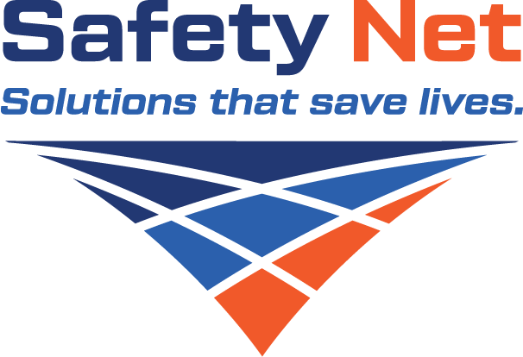

Questions? Please call 866-918-8546

* Warranty Registration must be received within 30 days of product delivery to be valid.

